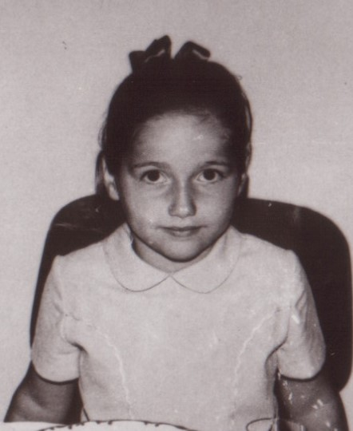

Number 1:

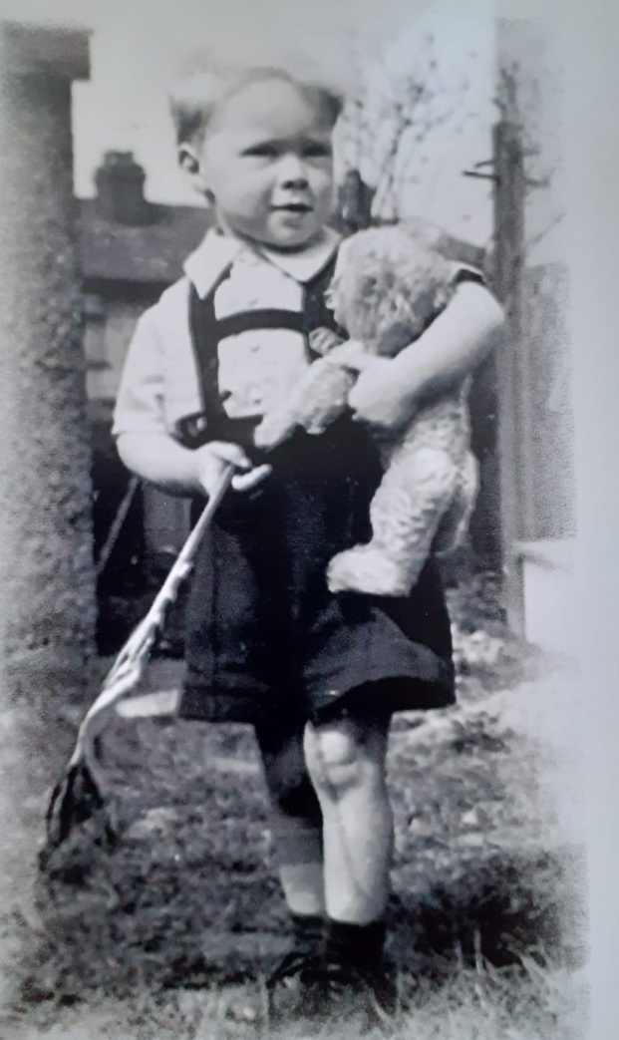

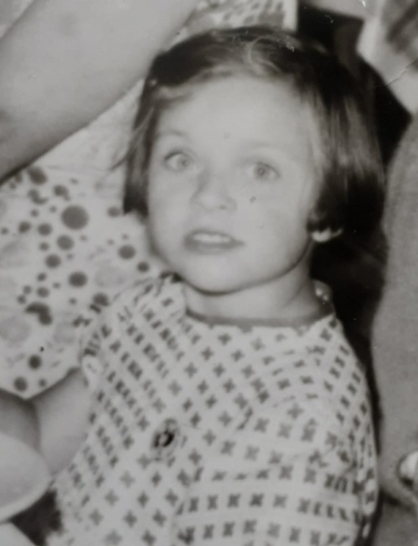

Number 2:

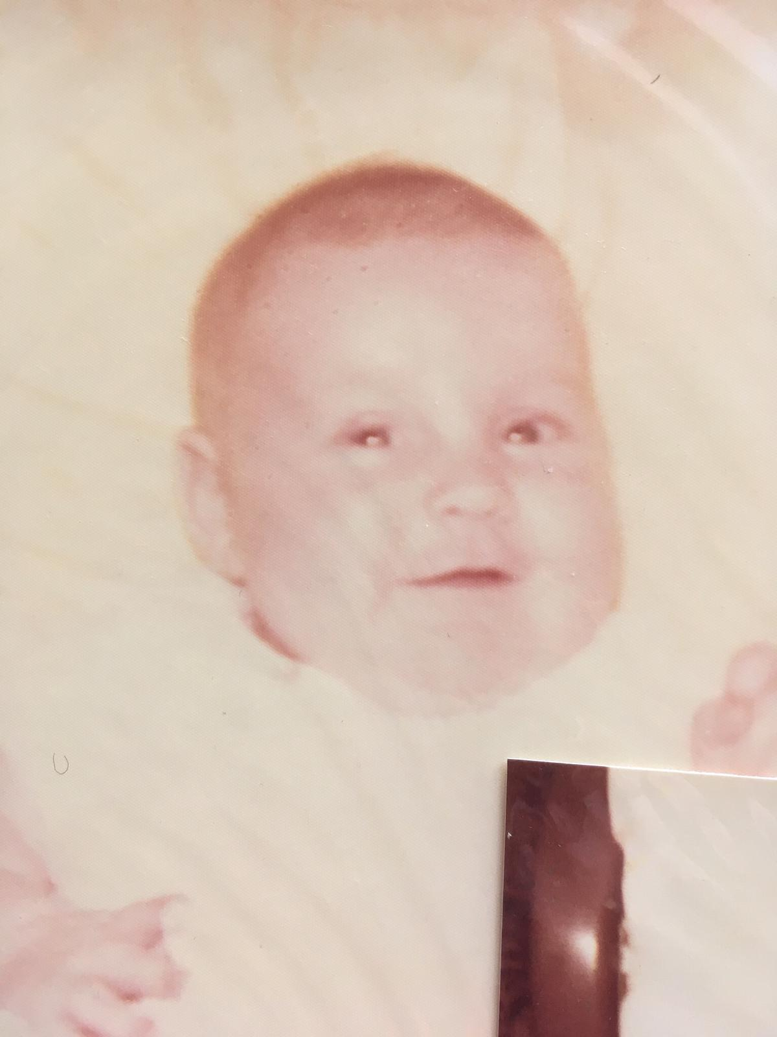
Number 3:
Number 4:

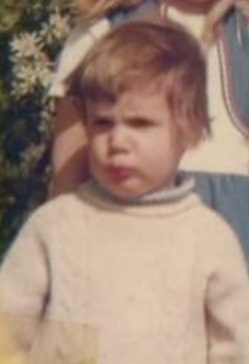
Number 5:
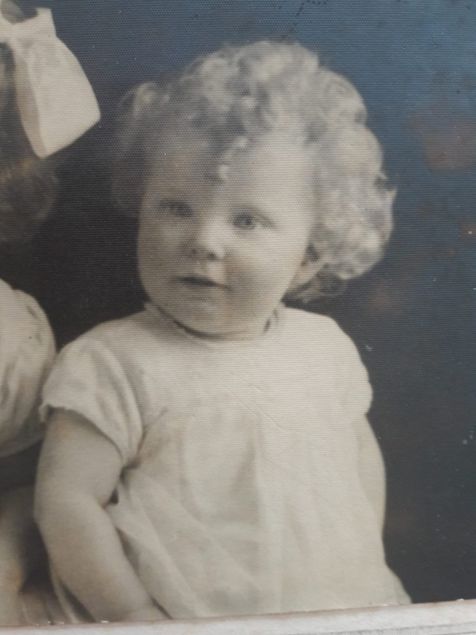
Number 7:

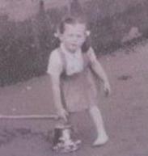
Number 6:

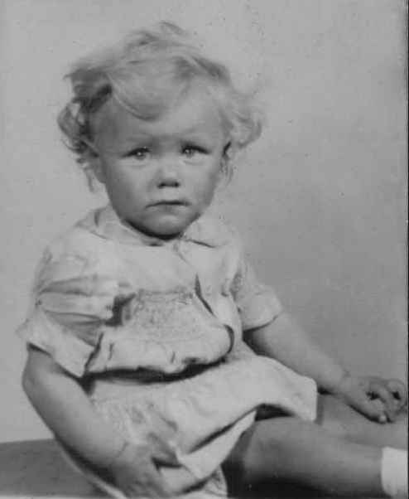
Number 8
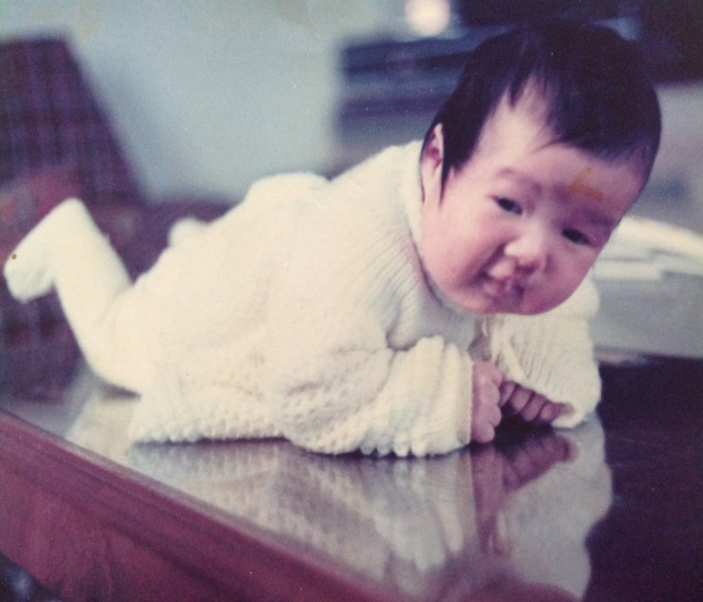
Number 9:

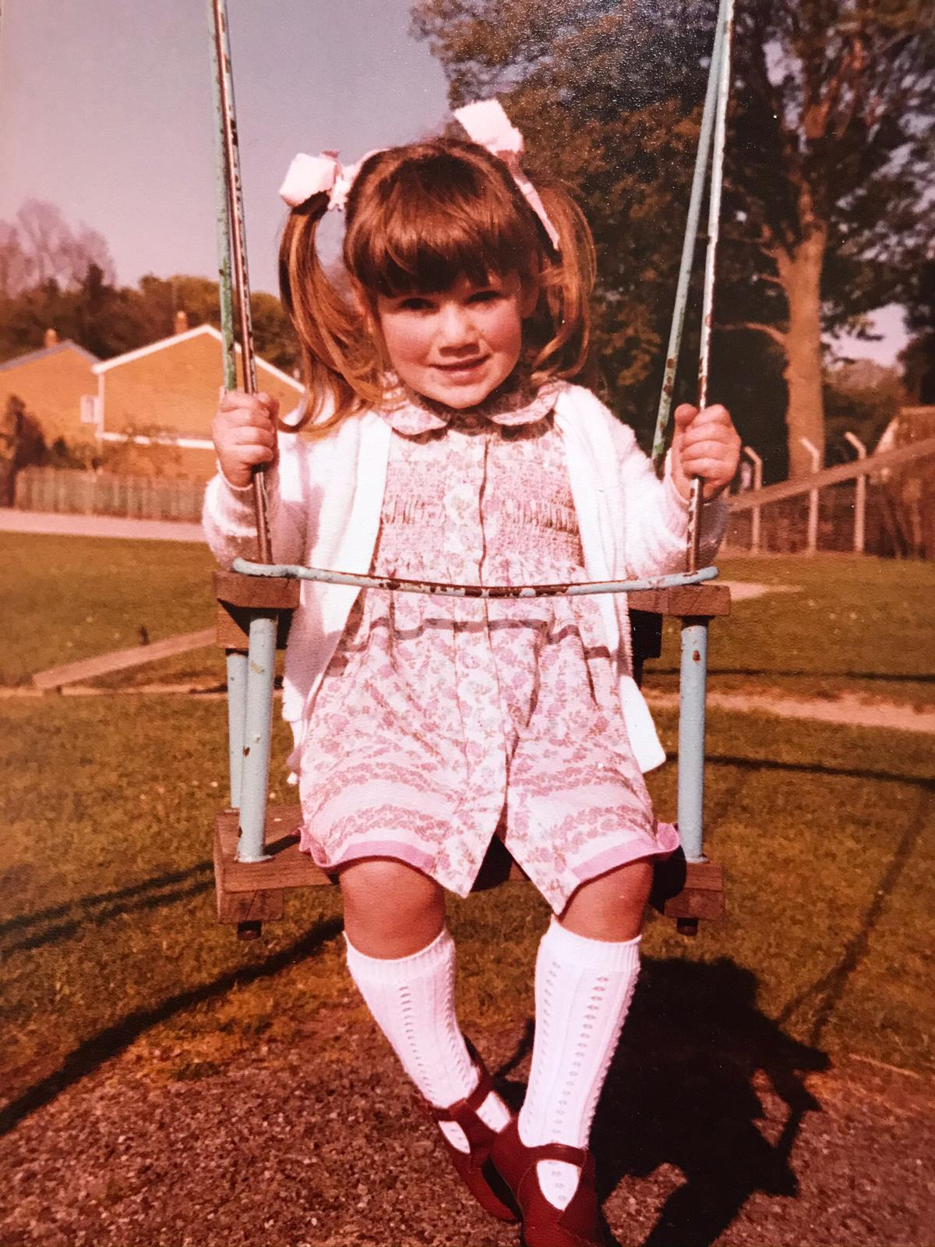

Number 11:
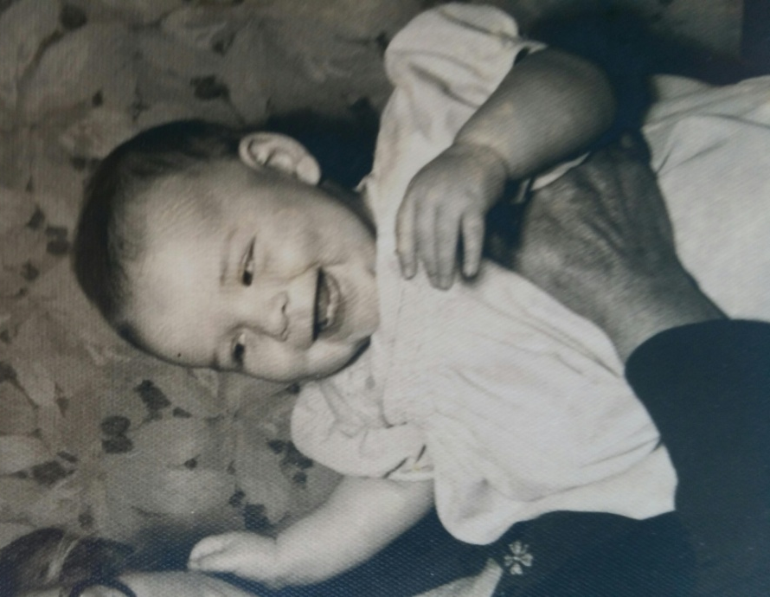

Number 10:

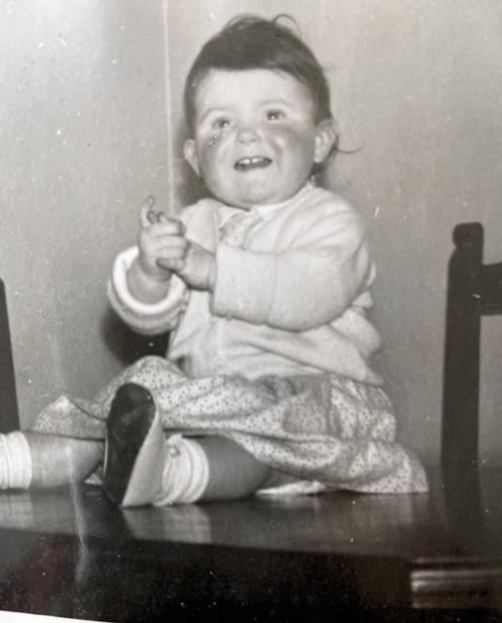
Number 12:

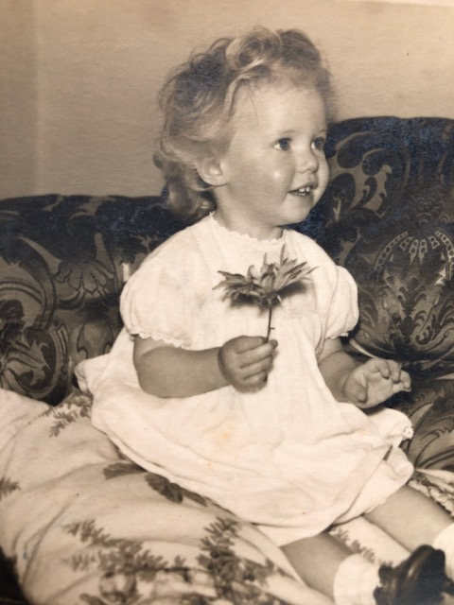
Number 13:

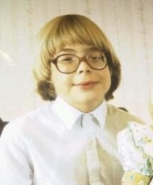

Number 15:
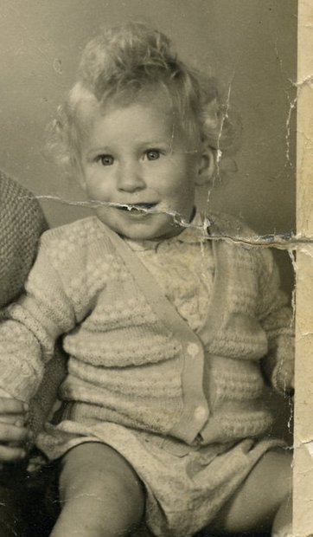
Number 14:

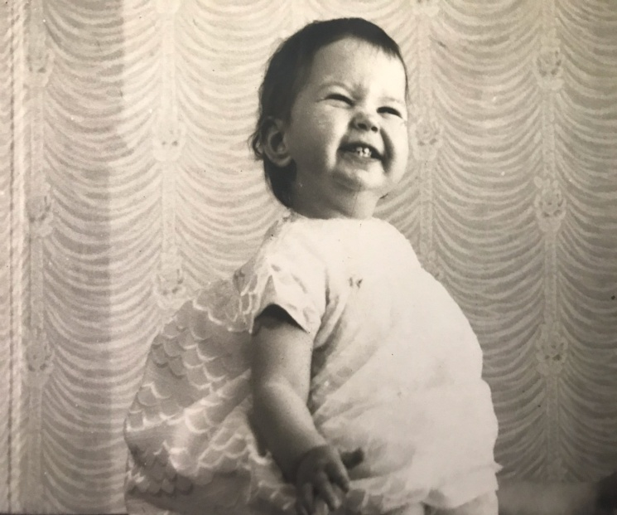
Number 16:
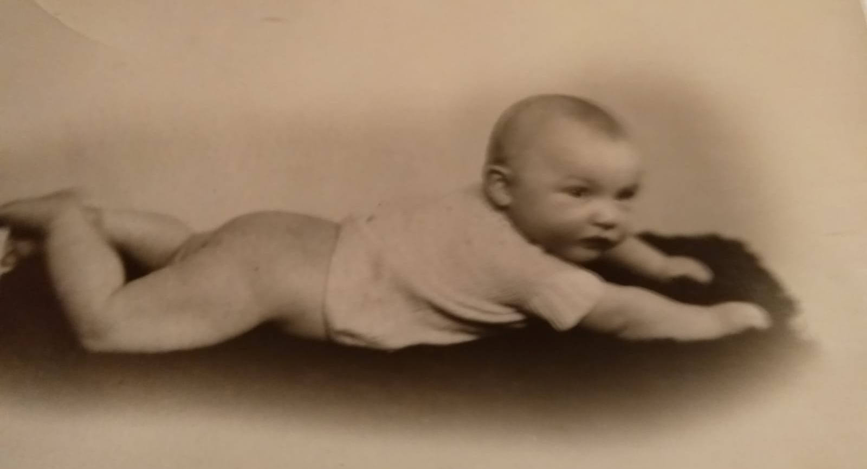

Number 17:
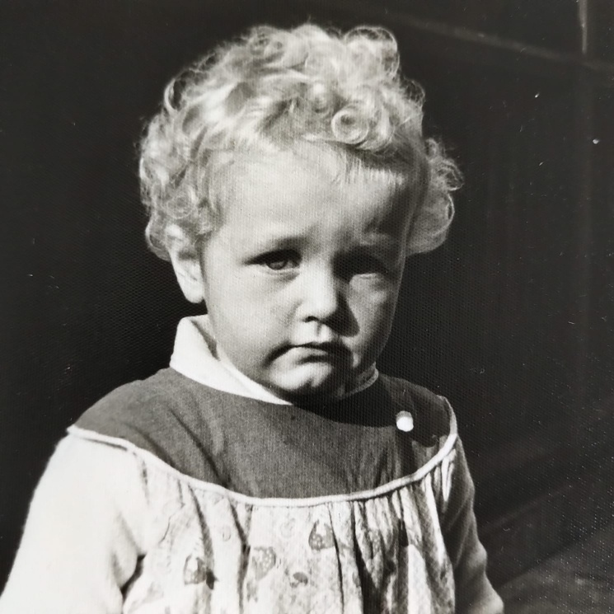
Number 18:
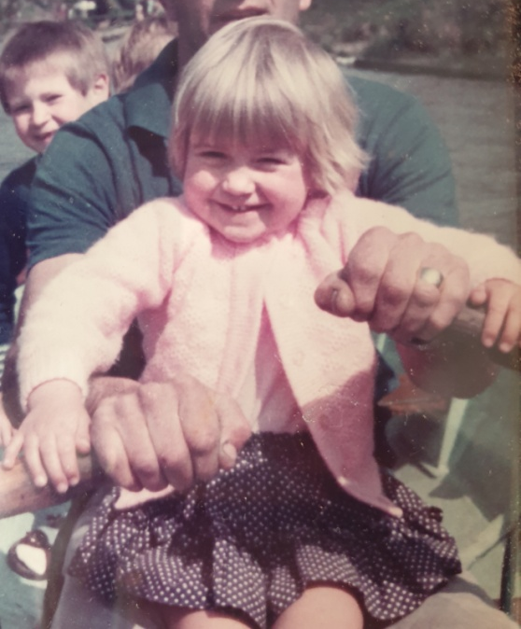
Number 19:
Who are the Blooming Babes?
Here is a list of the Blooming Babies for you to identify.
- Richard Landon
- Lesley Owen
- Trisha McClure
- John Modelski
- Hilary Stockill
- Ray Sothcott
- Janet Matthews
- Julia Clement
- Roy Miles
- Beryl Formston
- Bob Evans
- Laura McGuffie
- Carmina Drake-Francis
- Helyn Evans
- Maggie Browning
- Emily Walker
- Margaret McClure
- Emma Jones
- Ed Williams

Please put the correct name against each of the photos, or simply send a list in an email and return to Lesley at the email address
Lesleyowen21@gmail.com
There will be a book token prize for the most number of accurate guesses!
All entries should be with me by July 5th. Results announced July 12 ^{th}.
Good Luck!

