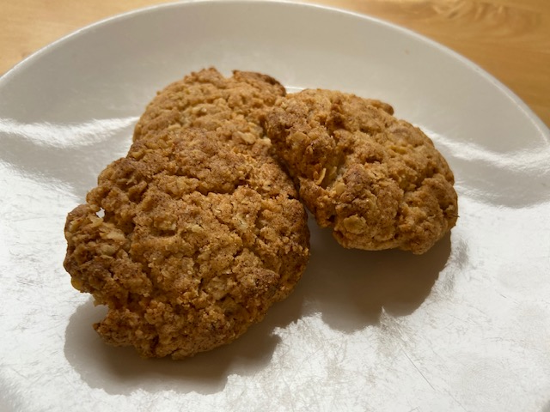Ginger biscuits

Ingredients

125g butter or margarine

125g granulated sugar

1tsp ground ginger 40g stem ginger finely chopped

100g porridge oats

125g self raising flour

1 TVs syrup (optional)

Suitable for vegans if vegan margarine is used

Method

Pre-heat oven 190°C fan/170°C forced/ Gas mark 5

Cream together margarine and sugar.

Combine flour, oats, ground ginger and mix with margarine until ingredients combine to a smooth paste. Add stem ginger.

Divide dough into 18-20 round balls.

Place on two lined baking trays.

Pop in oven and bake for 15-20 mins or until golden brown.

Final step is to pick out the biggest biscuit, sit back and enjoy.