Hello Everyone,
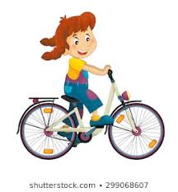
I hope that you all are keeping well, and managing to fill your days and keep busy during our days of lockdown. I thought to keep in touch with each other, and maintain that great sense of caring friendship that WCO is renowned for, it may be encouraging for us to share with each other what we have been doing during our days of separation in the form of a News Letter.

Life in Lockdown
Have you taken up new skills? Learnt a new piece of music? Set yourself a new challenge? Share your news with your friends at WCO.
So please email to me, the lesleyowen21@gmail.com and title it WCO News and we will email out as a news letter so we can catch up with each other

So here is our very first News Letter!
Thursday Night Thank You
I know many of you have joined in the regular Thursday evening Thank You to NHS and key workers. Some of you have even joined in with a musical tribute – you may have spotted our secretary, Margaret serenading on her flute and Ed on his trombone.
Youth Recaptured!
I wonder how many of you have joined me in resurrecting the old bike? Mine had lived in the garage for years, but with a can of oil and a few brillo bads, the transformation was amazing . So if you out and about in Meols/West Kirby look out for a rather wobbly red bike and rider.

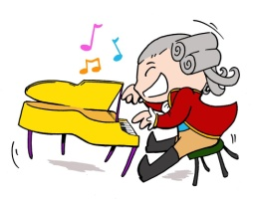
Musical Challenge
If you have given yourself a new challenge let us know! I have been (trying) to learn a favourite piano piece – Chopin Nocturen in Eb Major – Unfortunately my left hand is not very good at finding the right group of notes yet but I live in hope!

A Challenge For ALL
Dig out a piece of music you really enjoy and set it as a personal challenge to learn it or revise the playing of it. Remember to keep up the practise of the pieces we are currently learning, one day we will have a concert in which we can perform them – with perhaps a few more solo items too!
Keep making music and send in your news to lesleyowen21@gmail.com
Keep safe and stay alert
Lesley

