Hello Everyone,
Thank you all for your positive responses to our newly launched WCO News Letter.
Several of you have really taken this on board and sent in some super stories of how you have been filling the days and indeed raising money to help other causes. So please keep sending them in to me so we can keep in touch with each other even if we can’t make music together!
A special WCO welcome to Amanda who is keen to come and join us in the flute section – when life can start again.
Haute Cuisine From Pauline
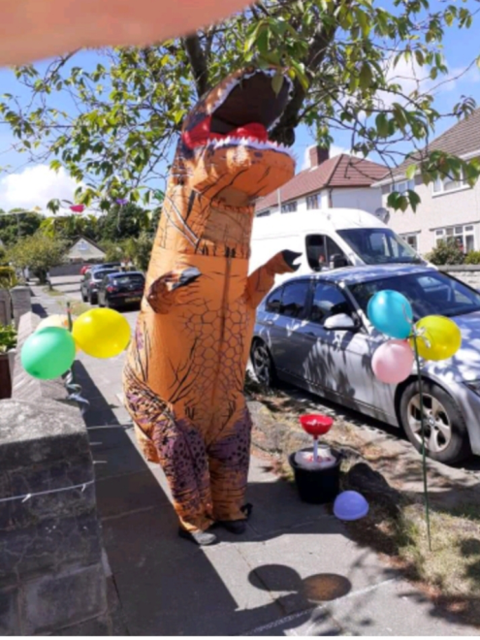
I'm still working (from home mainly) but have learnt to make bread and started cycling again.... 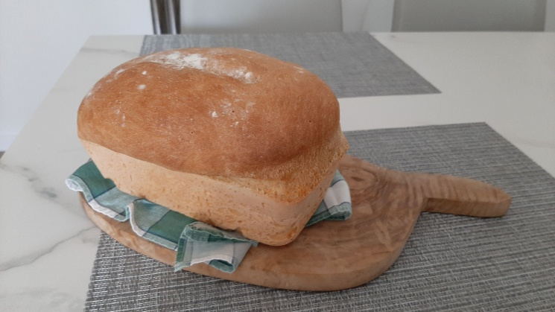
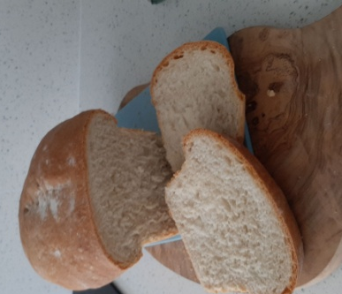
Every weekend we cook a themed dinner on Saturday night so we've done Italian, Mexican, Greek and French so far and lining up Indian, Chinese and Spanish.
What a Great Idea!
(I tried bread too – but a complete disaster!)
Beryl Raises Money for NHS

I personally love to stay busy (That is just ME I even drive myself nuts!) So I took the plunge and put a sign in my window to say, ‘V.E. day celebrations on your own front door step! Music, dancing, singing, a quiz (Albeit socially distanced) we had a great time.
Leading on from this I thought why not do something to raise money for the NHS? Epiphany moment!!!! Why not walk laps of the Cul De Sac? And why not make it a 1000!!! Money raised so far £150. The result was amazing as you can see from the photos!
Well Done Beryl- a brilliant Eureka moment!
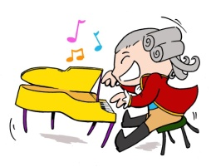
Helen Tickles the Ivories!
I have been using my time during Lockdown to spend more time playing both piano & keyboard. I had rather let piano playing take a back seat as I concentrated on learning saxophone and clarinet and participating in orchestras and bands.
I have treated myself to some new piano music of my favourite TV and Film theme tunes - some of which we have played at orchestra.
To give me some sort of goal I have offered to organise a musical quiz for my local Library Friend's Group for when we are able to reschedule our AGM in the autumn
We are so lucky to live in such a beautiful part of the world and I have used my allowed exercise time to walk for at least an hour a day mostly from home. This has allowed the exploration of new paths in the locality and appreciation of birdlife and wild flowers.

Thank you Lesley for reminding me how much I enjoy Chopin's Nocturnes - Perhaps we could do a duet of the Eb Major Nocturne with one of us doing the right hand and the other playing the left hand.

Great news Helen -I bagsy the right hand!!

Geraldine D.I.Y Expert!
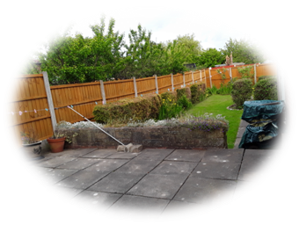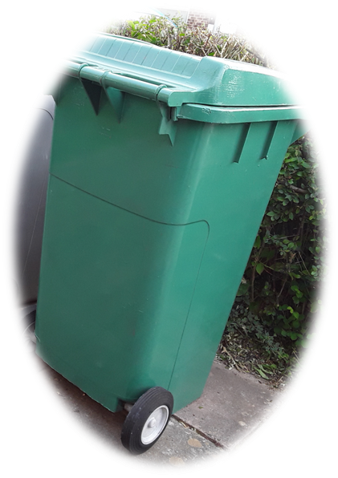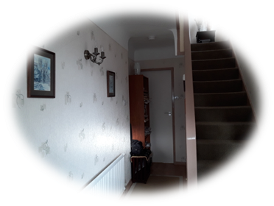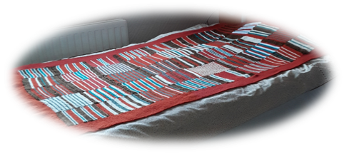Geraldine has been super busy at the home D.I.Y. Her achievements include a newly decorated hall, all garden fences all repainted, a knitted blanket made from pre-loved wool and a brown wheelie bin repainted green!

Hidden talents Geraldine!
Thanks to all for your news stories. Keep them coming and watch out for more next week!

Keep making music and send in your news to lesleyowen21@gmail.com
Keep safe and stay alert
Lesley

