Hello Everyone,
Thank you to all who have emailed to say how much you appreciate our news letter and feel it really does keep the spirit of the orchestra alive and helps us keep that sense of family WCO is so famous for.

A New Home for Emily and Ed
The easing of lockdown rules has brought good news to Emily and Ed. They have finally been able to complete their house sale and move to their new home together.
I just hope it has room for all Ed’s musical instruments. We wish them every happiness in their new home together.

Meeting the Family Again
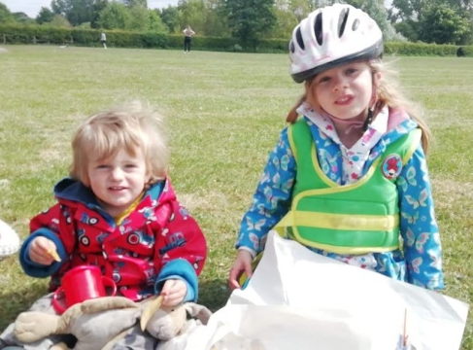
The easing of lockdown rules this week has also meant that families can be reunited again. I’m sure there are many of you like me have been long awaiting this day. So first time for 3 months, we had a trip to Manchester to visit our eldest daughter Judith and family. Grand daughter Emily (5yrs) has so missed us – she just burst into tears! Alex (18months & now fully recovered from his trip to hospital with Covid type illness) was keen to show off his football skills with Granddad.
We await Wales to catch up so we can visit my other daughter and family in Monmouthshire.

Ray Has Family Celebrations
Jenny and I celebrated our 51st Wedding Anniversary last Sunday and had a “Zoom” session last Friday with the rest of the family last Friday.

Our son (from Geelong in Australia) and our daughter and her tribe (who still live in Hertfordshire) her daughter – Lucy – was celebrating her 21st Birthday.
Other than that on Saturday we had a kind of street party in the bottom of our close – all done while respecting the right distances between families. It was a lovely afternoon – plenty of sunshine and good conversation with people who we seldom see other than fleetingly as we pass them.
Those at No2 are planning a Murder Mystery evening in the close 11th July – can’t wait to see how that goes.
Other than that, a fairly quiet relaxing time!

Laura is Busy at Work
Laura sends greetings to all and hopes we are enjoying this gorgeous weather (although I think we in for a change now!) She has been working throughout this craziness (NHS Infection Control Team for the Community Trust) it's been manic. To say that I enjoy every single day off I get is an understatement!

Chris Recovers from Covid-19
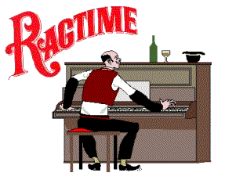
As an orchestra, we haven’t heard of many of our members suffering from Covid, but last week Chris emailed me the following:
Hi, I had the coronavirus and was quite ill for 7 weeks from the 2nd week in March until 5th May. My GP called an ambulance about week 4 but luckily my oxygen levels were ok so I stayed at home but I had trouble breathing and even now it's not right. I had antibiotics in the end. I've been back at work in Asda for 3 weeks now. It's a nightmare in there, customers are being quite nasty and shouting at us and even swearing at us for asking them to keep their distance. I had been in contact with 2 people who tested positive, both working in hospitals. Neither knew they had it when I saw them.
We are so glad to hear Chris is better and wish her a full recovery and better mannered customers! We send our best wishes to any other members who have suffered from this awful virus. Let us hope that the improvements we are seeing in the daily numbers each week mean that we are indeed controlling its spread.

Roy Reports on His Piano Progress
The Beethoven is going well, but in complete contrast I am now also working on some Scott Joplin music, based on a volume 'it's Easy to Play Ragtime'.
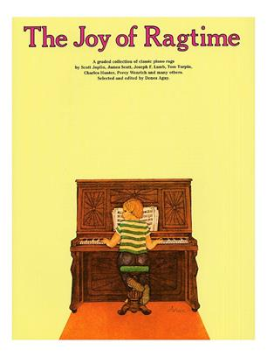
You may know that one of my interests (and ever since University) is New Orleans Jazz, and although I'm very familiar with Ragtime I've never played it to any great extent. It's really fun to play, and although not that 'Easy' the arrangements are excellent and can be found easily on YouTube.
(Lesley says: For anyone interested – great collection of Ragtime in The Joy of Ragtime, by York Town Music Press - £10.99 from MusicRoom).

Richard Keeps His Fingers and Feet Busy!
I spoke to Richard this week. He is well and continues his daily jog to keep fit. He also puts us to shame with his daily flute practice. (I’m afraid I’ve not been that disciplined- Lesley)

I’ve has so many people email to say how much they appreciate our “Lock Down News”, so please even if it’s just to say “Hello” , drop me an email for future editions.
Keep Safe Lesley
lesleyowen21@gmail.com

