Hello Everyone,
Thank you to all who have emailed your Lock Down News. It’s been great to have so much news. If you haven’t sent in your news yet – please do so for future editions.

Maggie’s Boots are Made for Walking!
I walk with the West Kirby Over 50’s Mountain Group once a week, so being in lock-down certainly clipped my wings. However, I have been surprised and delighted at discovering the number of circular walks there are on and around the Wirral. I have had the opportunity to explore the Wirral like never before, and it has been wonderful. Of course, the sunshine has been an extra bonus as well. However, not all paths have been boot friendly, so I will be glad when my shoe mender opens up. Because of the lock-down, I’ve a pair of walking boots and two sets of trainers in desperate need of heeling.
Catherine Learns Polish!
I have been working from home since mid-March so I haven’t really had any extra time. However, I’ve enjoyed going for a walk most days with my daughter and I must say it has been great being able to get up at a more reasonable hour! When I commute to Warrington I get up at 5:45am but when working from home I can get up later! The extra time in the morning means I have been able to spend more time on my Polish studies. I’ve been teaching myself Polish for about a year now and I miss practising with my Polish colleague at work. It’s a beautiful but very complex language to learn and I can’t wait to go to Poland.
Clare has Nimble Fingers!
I’ve been keeping busy during lockdown by getting back into baking. I’ve combined a ginger biscuit recipe with a cookie recipe to make a chewy ginger cookie/biscuit. This took quite a lot of baking and taste testing to get the recipe just right but I think I’m pretty much there now.
I’ve also been baking bread, not always a great success as some of the loaves are more like house bricks but I keep trying in the hope I will get the perfect loaf.
I have been out and about on my bike quite a bit. We are very lucky to have such beautiful countryside on our doorstep. I’d like to say I’ve been practicing hard on my flute but I haven’t. I did play ‘Over the Rainbow’ a couple of times on the Thursday night clap for the NHS though.
Crafting and creating is something I love to do so have spent quite a bit of time making cards for various occasions, doing embroidery called Kantha stitching, felting, Lino printing etc.
Alan Keeps His Pupils Busy and Learns to Cook!
It’s been an interesting experience trying to teach from home. My favourite fun activity has been the Sing-Along Challenge. I’ve selected songs with positive lyrics relevant to our current situation. The kids are having fun videoing their performances. Thankfully, I’ve so far avoided becoming “TikTok” famous!! Year 7 have a 1980s focus - ‘Don’t Worry Be Happy’ (Bobby McFerrin), ‘Don’t You Forget About Me’ (Simple Minds) and ‘True Colours’ (Cyndi Lauper). Year 8 have a 1960s focus - ‘Here Comes The Sun’ (The Beatles), Stand By Me’ (Ben E. King) and ‘What A Wonderful World’ (Louis Armstrong). If you need an endorphin boost, YouTube them and give them a go yourselves!!

At home, we’ve laid 20 metres of kerbstones in the garden, dug out and relocated 3 tonnes of soil to level a seating area and painted the outside of the house. I’ve also been doing more cooking than usual using real ingredients - I was shocked to learn Lasagne doesn’t grow on trees and that the cardboard box it normally comes in isn’t its natural peel!! We’ve been doing lots of video calls with family and friends - a virtual pub on Fridays complete with flashing fairy lights and virtual bowling tournaments using old Nintendo Wii consoles. Take care everyone and hopefully see you soon... Let’s hope the barber opens before then or I might need an extra chair to stop my long corona-hair touching the floor and getting stuck in my bow!!

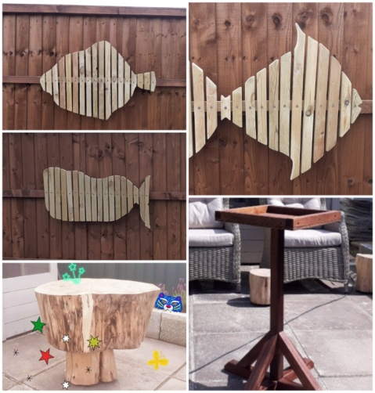
Beryl Masters D.I.Y
We have been busy transforming our garden...10 aviaries demolished and Summer House erected!! I have had many lessons on how to use a drill, sander, jigsaw and screwdriver! Here is the result of our labours...life in Lockdown and of course one hours practice thrown in the mix!

Carmina Beats Technology!
At the beginning of the lockdown I thought that I would have all the time in the world to finally practice cello as much as I wanted. It didn't turn out like that at all!
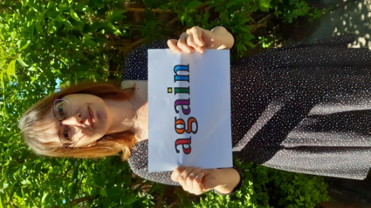
I have continued my work as an ESOL lecturer for a big FE college in Liverpool, trying to adjust to a variety of new online teaching methods. Nearly overnight, I had to learn how to use new "magic" tools such as MS Teams, Zoom, Padlet, Quizlet, Vocaroo, Mentimeter or how to narrate a Powerpoint presentation and save it to MS Stream!!
Together with my other colleagues, we have been doing our best to keep our students engaged, as they all miss coming to college and continuing their education. The highlight of this was a video which we made, sending a message of hope to our students. Each lecturer wrote a word, mine was "again", as you can see in this picture.
Helen Re-discovers Ragtime!
I continue to work on several pieces by Chopin from his Nocturnes, Mazurkas and Waltzes. I am currently working on several of each and making some progress - although fingers don't always work as fast as they used to.
I was very interested to read that Roy is playing some Scott Joplin as I am also rediscovering his "Rags". I started practicing "The Entertainer" for my musical quiz, but have since added in pieces like "Maple Leaf Rag", "The Easy Winners" and "Swipesy (Cake Walk) " from a book I have had since the 1970s called " King of Ragtime" which has over 30 pieces including songs.
We continue with our daily walks and have ventured a little bit further afield to explore walks around Willaston, Thornton Hough and Parkgate. It has been lovely to see my daughter and grandsons again, but have not managed to see our son who is in Manchester yet as the weather changed as soon as he was allowed to visit - still making do with Zoom sessions. He hopes to come over on Father's Day.
WKURC News
Although churches are allowed to open as of next week for private prayer, WKURC has decided not to open the premises until September, when it will need to review how the premises can be safely used by so many different groups whilst ensuring sufficient cleaning of the premises is possible to avoid contamination by surface contact. The main halls are used most days by at least two different groups. To comply with current risk assessments, it would need to clean the premises after each group use. I will update as I hear any further news.

Blooming Baby Competition
We are going to have a Guess the baby Competition and so we need you to send in your baby/ childhood photos. Scan and email to Lesley at email address below or Whats app photo to 07854991439.
Please send in by June 24th after which we will email out the entry forms fo all plus a link to the photos. There will be a book token prize for the winner!
Keep the news and photos coming and keep Safe
Lesley
lesleyowen21@gmail.com

