**Hello Everyone,**

Welcome to Week 6 of our **Lockdown News**. Thanks to all who have sent in their stories and a special thanks for the Blooming Baby photos. If you haven’t sent yours yet – please do so asap – it looks like its going to be great fun trying to identify who’s who!

**Email then to me at :** [**lesleyowen21@gmail.com**](mailto:lesleyowen21@gmail.com)

**or Whats App to 07854991439**

**Meet Up with Vicky**

Vicky and I had a lovely coffee and garden catch up on Saturday and shared our thoughts and hopes for the time when WCO can resume rehearsals.

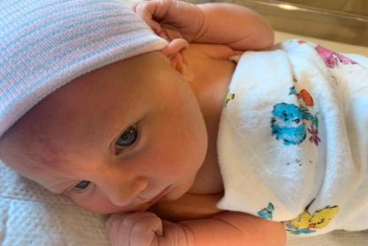**Vicky says:** Having now been furloughed, I have been enjoying having a little time on my hands for a change! It has been lovely spending time in the garden and working my way through the pile of books I have been meaning to read for ages.  I have started teaching my Mum to play the flute, something we have been talking about doing for years (she may be ready for orchestra by the time we get out of this!) and have sat down to play the piano properly for the first time in a long time. I am really missing orchestra though and look forward to when we can start back again.

**We shall look forward to our new flute recruit!**

**Many Triumphs for Steven**

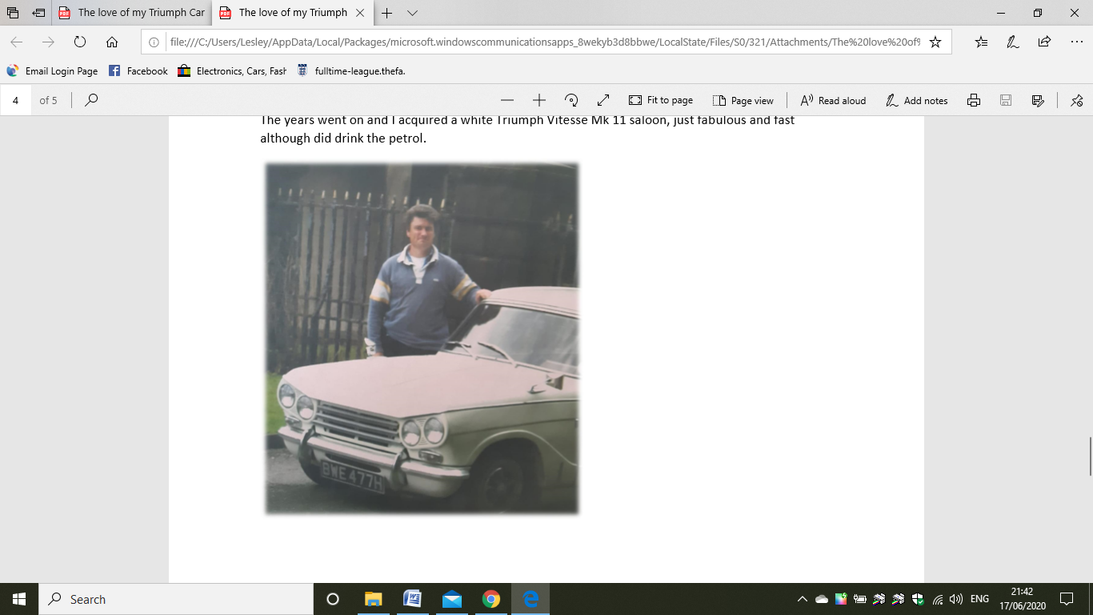In a phone chat with Steven, I discovered his fascinating passion for Triumph Heralds and Vitesse, which began when he was a young boy and had his first ride in one.

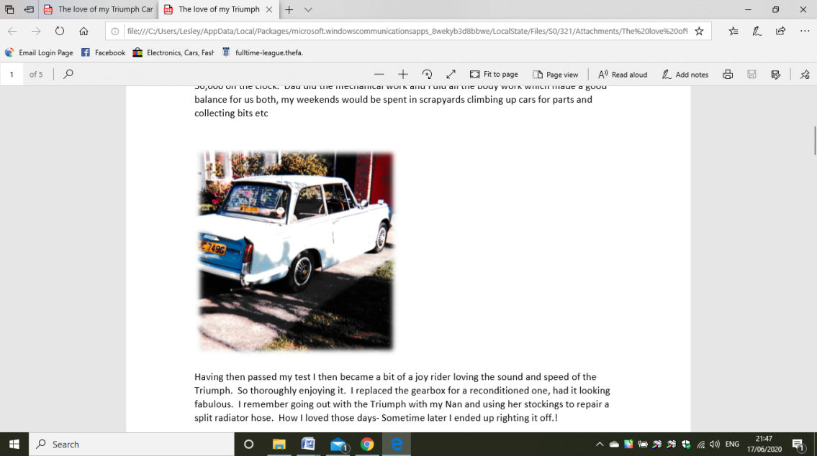Then the day came when I got my first triumph Herald 13/60 1969 saloon in Wedgewood blue with 50,000 on the clock. Dad did the mechanical work and I did all the body work which made a good balance for us both, my weekends would be spent in scrap-yards climbing up cars for parts and collecting bits etc. Having then passed my test I then became a bit of a joy rider loving the sound and speed of the Triumph. How I loved those days- Sometime later I ended up righting it off.!

I then started buying and selling doing them up and next I had a mark 4 red Triumph Spitfire with rotting doors! The years went on and I acquired a white Triumph Vitesse Mk 11 saloon, just fabulous and fast although did drink the petrol.

I currently have a white 13/60 convertible brought the bodywork up to reasonable standard. Finally, Liz and I acquired a blue Spitfire 1500, one of the last, this was given to us with the engine in bits due to engine seizure. I’m currently working on this with help from other Triumph enthusiasts.

**This is an extract from the full article Steven wrote for the Triumph Enthusiasts Club. See the attachment to read more of Steven’s Triumph adventures.**

**Hilary Has A Granny Award!**

Been quite a week for our family. Nothing to do with music but we have become grandparents for the first time. Noémie Margaret was born on the 10th June weighing 8 lb in Washington DC.

Mum, Dad and baby doing well.

Then at the weekend our son Robert got engaged to his lovely girlfriend Nel in the Netherlands.

Not to be left out our youngest daughter started a new job at Fact in Liverpool. An interesting experience when you have to go for a walk in the park to meet your new boss!

We will be quite happy to have no more news for a while!

**What a beautiful baby- our congratulations on your new addition to the family. Being a grandparent is great fun – but exhausting! Hope you get to meet her soon!**

**Out of the Blue Jazz Orchestra**

Some of you may have seen on the North West BBC News that one of our local bands was featured at the end of the show. You may recognise Izzy on trumpet and if you watch the clip – you’ll see Ed on the trombone. The orchestra is conducted by Becky Bell-Thomas from Heswall Concert Band – which many of WCO also play in. This video was recorded for the Music Venues Trust “Save Our Venues” campaign.

**Listen to the fabulous sound from Youtube link below:**

<https://www.youtube.com/watch?v=dP-KkkoE4mM>

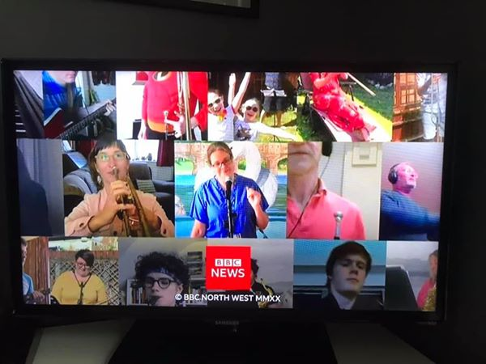

**Mike , Danila and Christine Garden Concert**

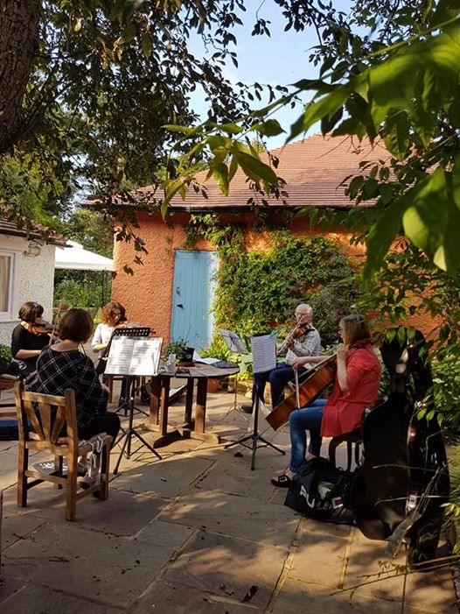

For the first time since lockdown the Sunlight Quartet (plus 1) got together and made music in Mike’s garden this evening. It was wonderful to play together again and feel ‘normal’ even though an insistent blackbird warbled away - out of tune - through all the pauses and the quiet bits!! However we did feel that Mike had gone a bit far by actually measuring the distancing between chairs with a tape measure before we got there!

**Ray Sends a Yummy Recipe**

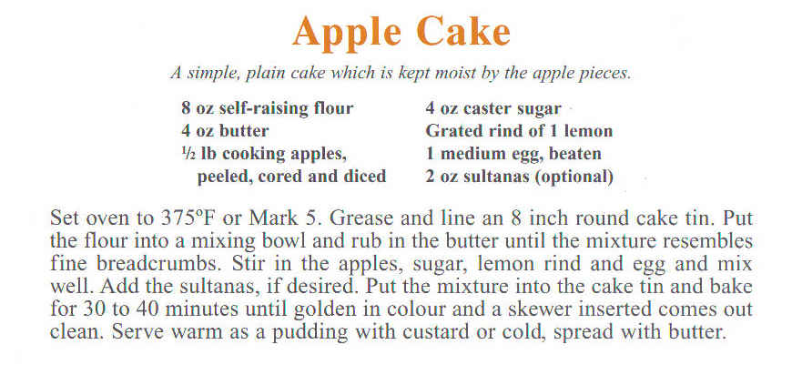

**Lesley Make a Riding Habit!**

My youngest horse mad daughter, Philippa challenged me to make her a side saddle riding skirt. She regularly competes for her home county of Monmouthshire and wanted a light weight navy one to match her riding jacket. She posted the pattern and her measurements and together with several Zoom meetings, and telephone calls, the finished item was posted back to her and was found to be a perfect fit! Now she wants a grey tweed one for winter competitions!

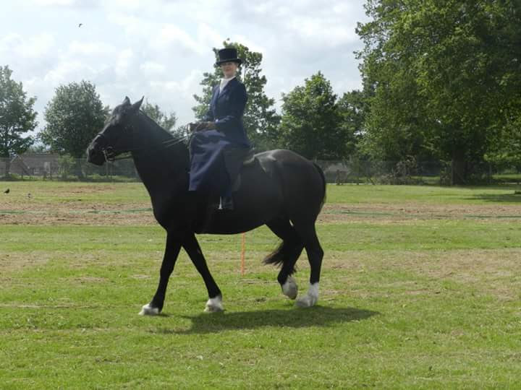

**Keep Sending the News and Photos**

If you haven’t sent your news yet – please do so for future editions. Our members do so much appreciate and enjoy hearing all the news.

**Lesley**

[**lesleyowen21@gmail.com**](mailto:lesleyowen21@gmail.com)