Hello Everyone,
Welcome to Week 7 of our Lockdown News. Thanks to all who have sent in their stories and a special thanks for the Blooming Baby photos. Have fun guessing who is each Bloomin Baby.
News of A Returning Member
Some of you may Peter Dobson who played violin and clarinet with us in the days of Wirral Co-operatiive Orchestra. I heard from Peter this week, who having recovered from a period of ill health, is keen to join in with us again – as soon as we can start rehearsing together again. For now, he is keeping in touch via the New Letter and the website.

Margaret Joins Online Harmonie Tunes
I was scrolling through Facebook a few weeks ago and I can across Harmonie Concert Band based in Solihul, and they were inviting all musicians to join them. So can you spot me on the flute?

Check out the link below – hope you enjoy it:
https://youtu.be/WB1iGBk_VAQ

Laura Joins A Record Breaking Harp Concert.
Hello everyone! Hope everyone is keeping well, and staying sane!! My days seem to be blurring into one lately, but I managed to find some down time to get involved with one of those projects where you record yourself playing, and then some poor soul has the unenviable task of painstakingly glueing them all together to form a recognisable piece. A record breaking 109 harpists of all abilities joined together to play Pachelbels Canon. If you fancy a watch, you can view it online here :
https://youtu.be/Ti-dhSudIVc
I wonder if you can spot me? Apparently it took over 200 hours to edit and produce! I’m so glad that wasn’t my job!
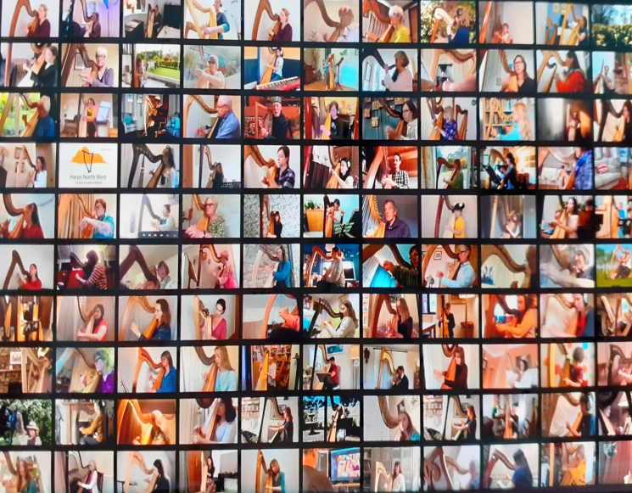
Now that gives Laura an idea . . . .John, fancy doing one of these for our orchestra in between fixing your boat . . . it won’t take you long!!
Covid 19 Update and WKURC Halls
The latest easing of the lockdown restrictions do bring us some hope for the future, providing all continues as it is and there is no uptick in the rate of infection or the number of Covid-19 cases. Despite church buildings now being allowed to open, WKURC have decided not to re-open the buildings until September when they review the situation and, if conditions allow, will begin to open the premises in October, provided we can provide and abide by any necessary risk assessments, which I hope to work on and circulate in August, for operating safely under Covid restrictions. So fingers crossed we may be able to start up in some form early autumn.
Jack’s Description of a Conductor - All in Good Fun!
This is an extract from an article Jack sent in – the full article, was a little too long to include fully can be read in the attached file. The extract is taken from an interview given during his student days.
JD: Conductors are strange creatures. And I suspect that more than one has a “screw loose”. For example, they frequently forget to bring their music onto the platform with them and end up trying to do the concert from memory to cover their embarrassment. They’re also contrary fellows, excitable and subdued in abrupt turns, at one moment full of energy, but followed by periods of torpor with barely a movement to indicate that they’re not fully comatose.
SS: I understand that you have had some significant contretemps with conductors in the past.
JD: I think, overall, that I cope pretty well with conductors, although it’s not always easy, especially given their almost universal shyness.
SS: Universal shyness?
JD: I’m referring to the invariable stage fright which afflicts ALL conductors when they finally have to perform in front of a live audience. At rehearsal, the conductor is a paragon of communication, counting time aloud, shouting directions, and clearly and openly saying what he wants: FASTER! LOUDER! SLOWER! QUIETER! Etc. However, in a performance the same previously voluble fellow loses the power of speech completely, and is reduced to a pathetically ineffectual form of waving and semaphores.
SS: It’s been said about you that you never look at the conductor. Is this so?
JD: Nothing could be further from the truth! Whilst playing, I fear to turn my gaze away from these fellows for an instant! If I should ever see a maniacal conductor take one step towards me from his podium, then I’m off! Some of them are armed with sharp sticks, you know!
Fortunately our conductor, John is nothing like this!
Summer Break
Thank you to all who have helped to keep the spirit of the orchestra together during this lockdown by sending in your news and photographs for our weekly Lockdown News.
We are taking a summer break from weekly news, but not stopping completely. We would like you to send in your Holiday Staycation News and/or photos or indeed if you do travel abroad, your Foreign Holiday News and / or Photos. We hope to send out Lockdown News editions in late July and August and build up a travel map to see where we all travel to post lock down!
For me, I’m so looking forward to Wales being accessible again so I can visit family – and my youngest grand son whom I haven’t seen since his first birthday on February 1st.
So take care every one, keep making music, keep safe and most of all keep sending in your Staycation and Holiday News so we can keep in touch over the summer and share those places we have visited.

Oh and Don’t Forget:
Please see the two attachments:
- Blooming Babies
- Jacks full interview article.

Fingers Crossed we can play together again soon!
Lesley
Lesleyowen21@gmail.com

