Hello Everyone,
Welcome to Week 8 of our Lockdown News. I’ve had great fun sorting out all the entires to our Blooming Baby Competion – especially as one entry failed to recognise their own photo they had sent to me!! ( I did give a chance to correct as they had clearly mixed up numbers).

Birthday Greetings
This week our secretary Margaret celebrated her birthday on 30th June. WCO send our best wishes and hope you had a lovely day.

Happy Birthday Twins!
Many of you will remember Christine who played flute with us for several years before having a break for the birth of her twin boys, Alex and Luke who celebrated their first birthday on June 28th. We send our congratulations and best wishes to Christine, husband Chris and family of five boys!!!
Welcome to New Member Michelle
When we can start up again, we will welcome another new member, Michelle Moran, who like many folk has returned to playing music during these days of lockdown and hopes to join us in the clarinets when we resume.

Tricia Tempts our Taste Buds!!
Strawberry ice cream.
1 large tub double cream,,1 mug sugar, 1 large punnet strawberries, chopped.
Tip all the ingredients into the blender and blend till smooth. Freeze in suitable container. Remove from freezer 15 mins before serving. Keeps for months. If you find it crystallises slightly after several months, slightly defrost and blend again.
Raspberry Ripple ice cream.
Slightly more complicated but worth the effort, works with any soft fruit and any flavour curd. I specially love mango and passion fruit curd.
150ml double cream, 150g lemon curd, 100g raspberries, fresh or frozen,1tbspn golden syrup,1 tbspn caster sugar.
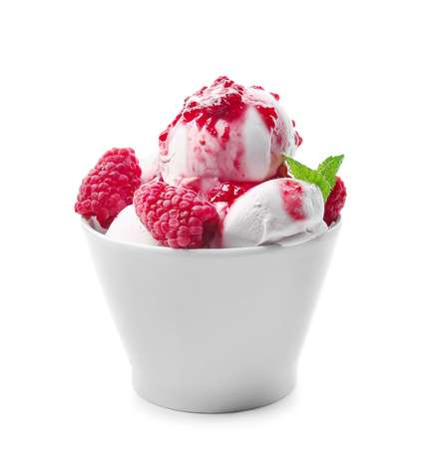
Whisk double cream, fold in the curd. Chill in fridge for 1 hour. Meanwhile place raspberries, golden syrup, caster sugar and I tbspn water Cook gently for about five minutes till sugar has dissolved and fruit collapsed. Push raspberries through a sieve to remove seeds. Return the sauce to the pan, bring to the boil, simmer for 2 minutes then leave to cool.
When the hour is up, put half the cream mixture into shallow container. Use a teaspoon to pour lines of raspberry sauce across the cream, then use a knife or spatula to pull lines of sauce across in the opposite direction. Gently top with the remaining cream mixture and repeat the process. Freeze . Remove from freezer five minutes before serving as it doesn’t usually set as hard as the strawberry ice cream. I usually double the quantities, which works just as well. Hope you like them, Tricia x
Check out Music Room for some sheet music to keep you busy over the summer break. Free delivery for orders over £15
Remember to send in your guesses to identify our Blooming Babies. You may be the lucky winner of the book token. Results out next issue. Send as a list by email to Lesley at lesleyowen21@gmail.com.
Lesley meets the Grandchildren
Last Thursday we had a lovely catch up day with our eldest, Judith and her two children Emily and Alex at the nearby Lymm Dam. We hadn’t been here together since before the lockdown so it was good to re visit a favourite spot. Despite the dreadful torrential rain Ted and I drove through on the M56 by the time we reached Lymm the sun had come out and it was actually quite warm – despite our clothing attire! Alex was wearing his new blue wellies and discovered the art of jumping in muddy puddles – just like Peppa Pig does ably taught by Emily sporting her new pink sparkly wellies – with flashing lights when you jump in puddles! Both enjoyed feeding the ducks and exploring the dinosaur foot print!
On our walk around the dam we spotted this fabulous no litter notice. I thought we could do with some of these on the beaches, parks and Pier Head to shame those litter louts of recent days. We had a good laugh at this.

If you looking for a nice woodland walk and a pretty village nearby with ducks to feed, and nice coffee shops plus a nearby canal walk, recommend Lymm Dam. Some parking adjacent to the dam and a car park further along by the church.
More Recipes to Enjoy
It seems that many of our members are also superb cooks! Here we have two more delicious recipes to tempt your taste buds.
- Clare sends us Ginger biscuits
- Ray sends us braised lamb steaks
Please see the attachments for the recipes- and do let us know if you like them – the ginger biscuits are scrumptious!
Escape from LockDown: Photo Snap News Wanted!
During the summer break I’m sure you will all have that special moment, event or place captured on your phone or camera or perhaps a postcard of a special place you have visited. Send them into me so we can make a photo history of WCO Days or indeed if you are adventurous and manage a trip to foreign parts! A prize for the best entry!!!
Please email or whats app your pictures to Lesley at:
Lesleyowen21@gmail.com or Whatsapp: 07854991439
Summer Break
Thank you to all who have helped to keep the spirit of the orchestra together during this lockdown by sending in your news and photographs for our weekly Lockdown News.
We are taking a summer break from weekly news, but not stopping completely as we hope to have an issue mid August and again mid September when we hope to have more news from the Church regarding its Covid Risk Assessment policies for hall users.
So take care every one, keep making music, keep safe and most of all keep sending in your Staycation and Holiday News so we can keep in touch over the summer and share those places we have visited. For me – I’m off to Wales to visit the family not seen since February 1st!! So look out for the farm photos!
Lesley
Lesleyowen21@gmail.com

